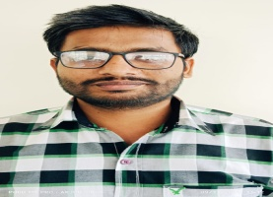**RESUME**

**Guru Nanak Nagar, Bhulana ,Kapurthala.**

**8557927725, 7888365852**

**VikramKumarsingh.kpt@gmail.com.**

**Vikram Kumar Singh**

## 

## Objective :

**To secure a position that challenges my skills and urges me to learn and enhance my capabilities and experience.**

## Skills :

* **C/C++, Python**
* **HTML + CSS**
* **Microsoft Office**

## Projects :

**The Project is based on Asp.Net and Database in MYSQL. The project is about E-Commerce in which we also provide different types of services and products related to domestic RO Systems**.

## Strength :

* **Hard Working + Smart Working**
* **Punctual**
* **Sincere**

## Education :

| QUALIFICATION | UNIVERSITY | PERCENTAGE/GRADE |
| --- | --- | --- |
| Bachelor Of ComputerApplication | GNDU | 61 |
| HSC | PSEB | 63 |
| SSC | CBSE | 7.2 (CGPA) |

## Additional INFO. :

## Father’s Name : Dilip Singh

**Mother’s Name : Sarojani Devi**

**D.O.B : 22/12/1996.**

**LANGUAGES : Hindi, English, Punjabi.**

**HOBBIES : 90’s instrumental music.**